1085-10 (CO)

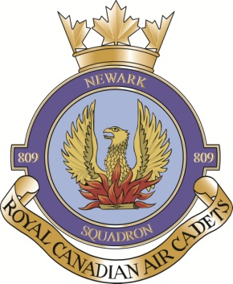
809 Newark Squadron
Royal Canadian Air Cadets
P.O. Box 1192
Virgil, ON
L0S 1T0

REMEMBRANCE DAY 2013
Dear Principal/Teacher,
Please excuse members of 809 Newark Squadron Air Cadets from classes on Monday 11 November 2013 as they are attending two parades in honour of Remembrance Day.
They will be participating in a Vigil at the Cenotaph in Niagara-On-The-Lake beginning at 645am on Monday, followed by the Town Parade at 11am. Afterwards, they will be attending the Queenston parade at their Cenotaph then enjoying lunch with our local veterans at the Royal Canadian Legion Branch 124.
Some of our cadets will be participating in school ceremonies. They are authorized to wear their Air Cadet Uniform for this important occasion.
I encourage you to speak with them about why Remembrance Day is important, what it is about Air Cadets that they enjoy, and to visit our website: www.809cadets.ca for more information about Canada’s premier youth program.
Sincerely,

(original signed)
T. Palumbo
Captain
Commanding Officer
809 Newark Sqn
(905)468-7584

